RISING WATERS
Flood Prediction System using Machine Learning and Flask

1. INTRODUCTION
Floods are one of the most destructive natural disasters, causing severe damage to human life, agriculture, infrastructure, and the environment. Predicting floods in advance helps governments and disaster management authorities take preventive measures and reduce losses.
The Rising Waters project is a machine learning-based Flood Prediction System that predicts whether a flood is likely to occur based on environmental and weather parameters such as annual rainfall, seasonal rainfall, temperature, humidity, cloud cover, and geographical subdivision.
The project uses machine learning algorithms to analyze historical weather data and classify flood conditions as either Flood Likely or No Flood. The trained model is integrated with a Flask web application that allows users to enter weather details and receive instant predictions.
The system provides:
- Early flood prediction
- User-friendly web interface
- Fast prediction using Machine Learning
- Reliable decision support for disaster management
TEAM MEMBERS :
NAME | ROLE
Bonda Devi Vamsitha | Team Lead
Chandika Venkata Krishna Bhanu Teja | Team Member
Dhanushkoti Chukka | Team Member
Sai Manasa Nikhita Dasari | Team Member
Tripura Dwarampudi | Team Member

2. SCENARIO-BASED CASE STUDY
Scenario: Flood Risk Prediction
A disaster management officer wants to predict whether flooding is likely in a particular region.
- The officer opens the Flood Prediction website.
- The officer enters weather details such as:
  - Temperature
  - Humidity
  - Cloud Cover
  - Annual Rainfall
  - Jan-Feb Rainfall
  - Mar-May Rainfall
  - Jun-Sep Rainfall
  - Oct-Dec Rainfall
  - Average June Rainfall
  - Subdivision
- The user clicks the Predict Flood button.
- The trained machine learning model processes the information.
- The application displays either:
  - Flood Likely
  - No Flood
- Authorities use the prediction to prepare rescue operations and issue public alerts if necessary.

3. OBJECTIVES
The objectives of the project are:
- Predict flood occurrence using historical weather data.
- Reduce flood-related losses through early warning.
- Compare multiple machine learning algorithms.
- Select the best-performing model.
- Deploy the prediction model using Flask.

4. TECHNICAL ARCHITECTURE
The Rising Waters application follows a Machine Learning–Web Application architecture.
Frontend
- HTML5
- CSS3
- JavaScript
Provides the user interface for entering weather details.
Backend
- Flask
- Python
Processes user input and communicates with the machine learning model.
Machine Learning
- Scikit-learn
- Decision Tree
- Random Forest
- KNN
- XGBoost
Used for model training and prediction.
Database
Dataset stored in CSV format.

5. SYSTEM ARCHITECTURE
User
↓
Flask Web Application
↓
Input Validation
↓
Machine Learning Model
↓
Flood Prediction
↓
Display Result

6. ER DIAGRAM
User
Attributes
- UserID
- Name
- Email
- Role
Weather Data
Attributes
- Temperature
- Humidity
- Cloud Cover
- Annual Rainfall
- Jan-Feb
- Mar-May
- Jun-Sep
- Oct-Dec
- Average June Rainfall
- Subdivision
Prediction
Attributes
- Prediction ID
- Flood Status
- Prediction Date

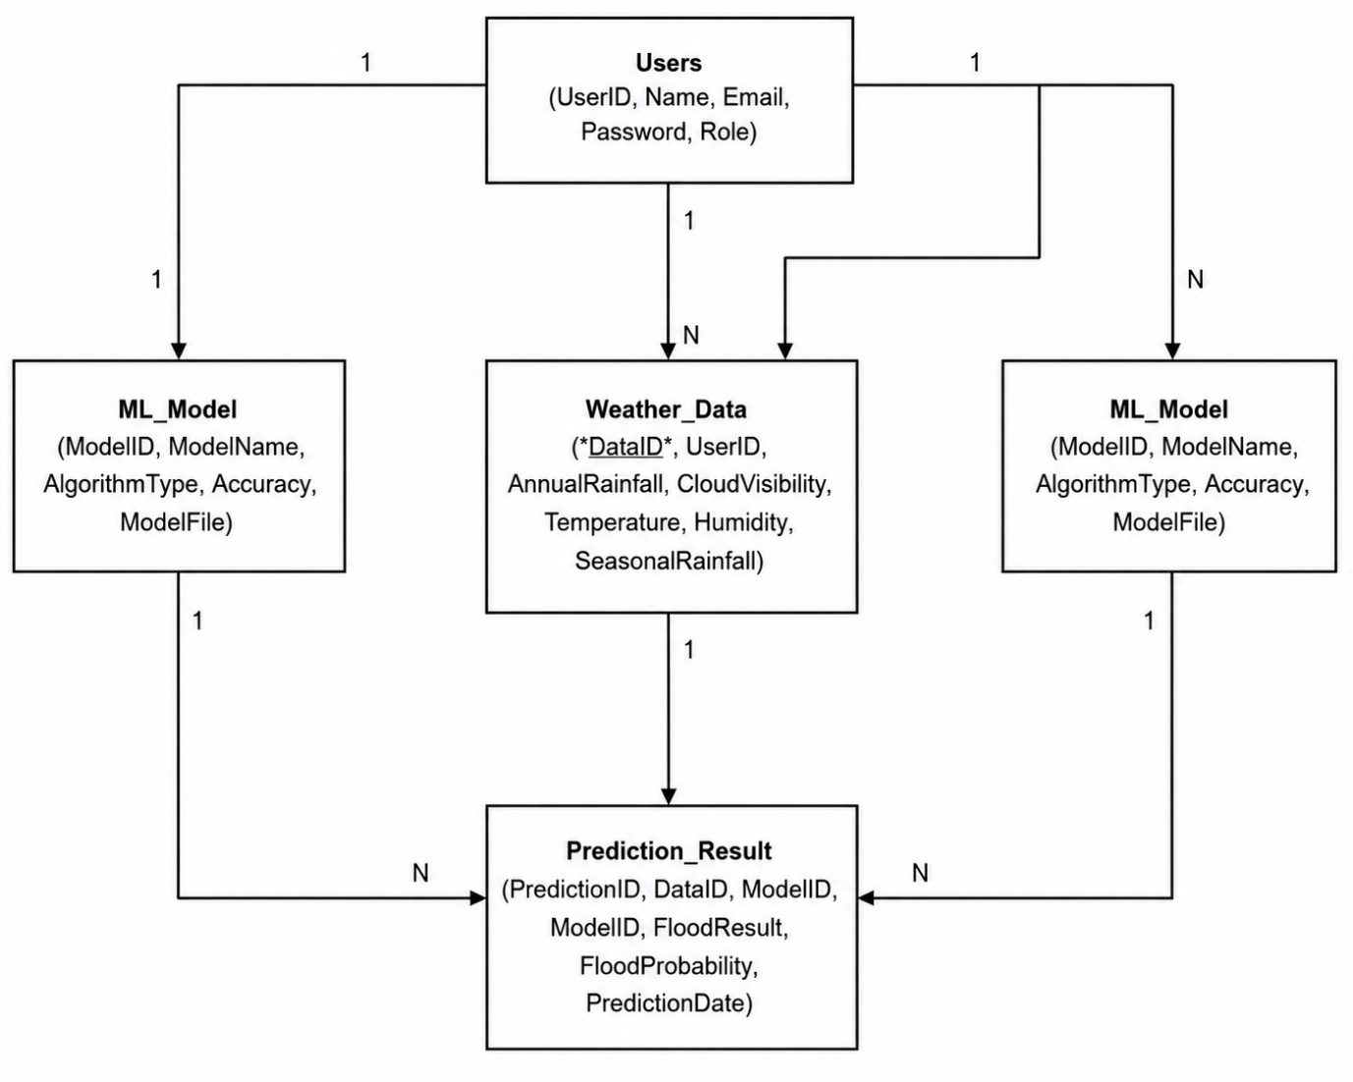

7. PREREQUISITES
Software
- Python 3.x
- Anaconda
- Jupyter Notebook
- VS Code
- Flask
- Scikit-learn
- Pandas
- NumPy
- Matplotlib
- Seaborn
- Pickle

8. REQUIRED LIBRARIES
numpy
pandas
matplotlib
seaborn
scikit-learn
pickle
flask

9. DATASET
The project uses a historical flood prediction dataset containing weather and rainfall parameters.
Features include:
- Temperature
- Humidity
- Cloud Cover
- Annual Rainfall
- Jan-Feb Rainfall
- Mar-May Rainfall
- Jun-Sep Rainfall
- Oct-Dec Rainfall
- Average June Rainfall
- Subdivision
Target Variable
- Flood (0 or 1)

10. DATA PREPROCESSING
The following preprocessing steps were performed:
- Reading Dataset
- Missing Value Detection
- Outlier Detection
- Feature Scaling
- Splitting Features and Target
- Train-Test Split

11. EXPLORATORY DATA ANALYSIS
Performed using
- Histogram
- Box Plot
- Heatmap
- Correlation Matrix
- Descriptive Statistics

12. MODEL BUILDING
Models trained:
- Decision Tree
- Random Forest
- K-Nearest Neighbors
- XGBoost
Performance metrics:
- Accuracy
- Confusion Matrix
- Precision
- Recall
- F1 Score

13. MODEL COMPARISON
The performance of all four models was compared.
The model with the highest accuracy was selected as the final prediction model.
(If you know which model gave the best result in your notebook—Decision Tree, Random Forest, KNN, or XGBoost—you can mention that here.)

14. MODEL SAVING
The trained model was saved using Python Pickle.
flood_model.pkl
The Flask application loads this file during prediction.

15. PROJECT STRUCTURE
RISING-WATERS/
│
├── app.py
├── flood_model.pkl
├── flood dataset.csv
├── rising-proj.ipynb
├── templates/
│ index.html
│ chance.html
│ no_chance.html
├── static/
│ main.css
│ main.js

16. APPLICATION FLOW
Start
↓
Enter Weather Details
↓
Click Predict
↓
Flask receives input
↓
Model Prediction
↓
Flood Likely / No Flood
↓
End

17. PROJECT IMPLEMENTATION
index.html:
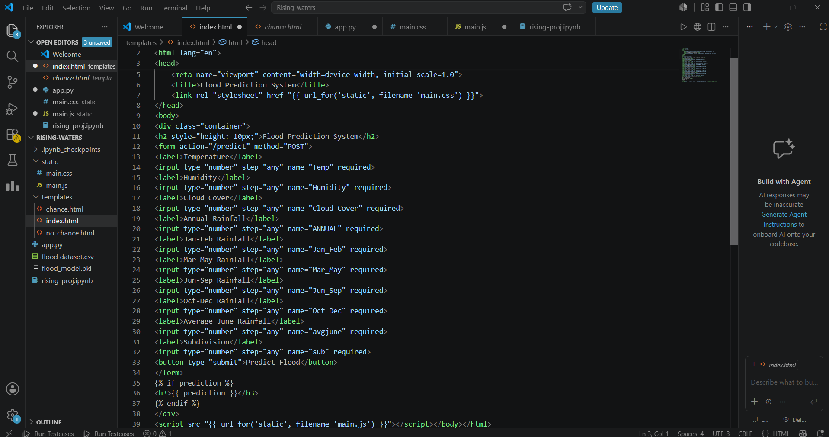

chance.html :
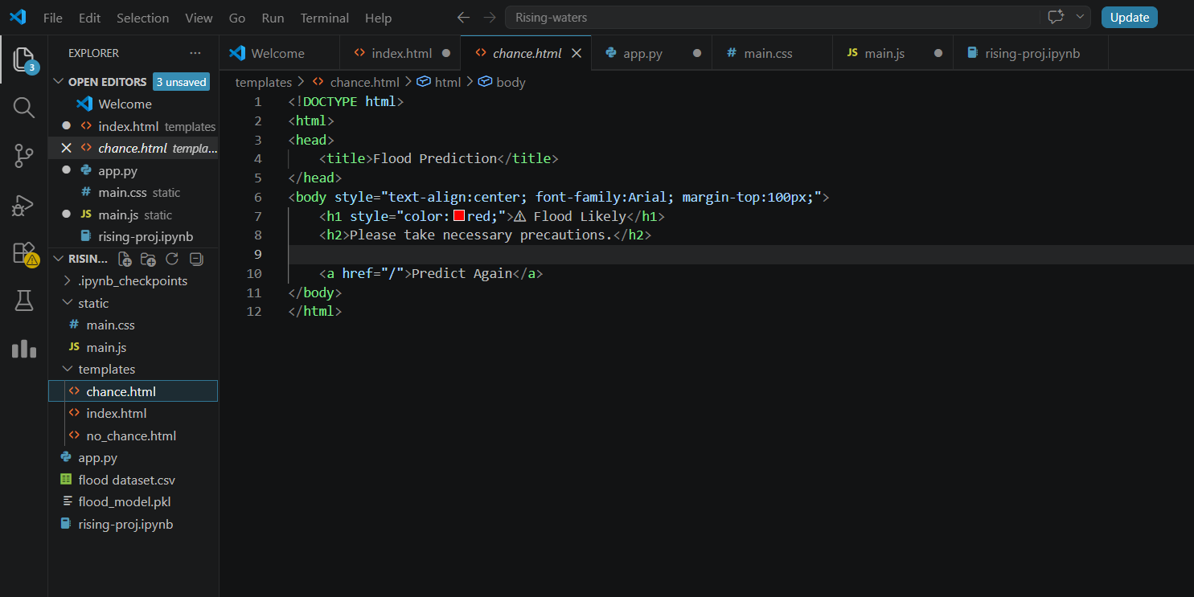
nochance.html :
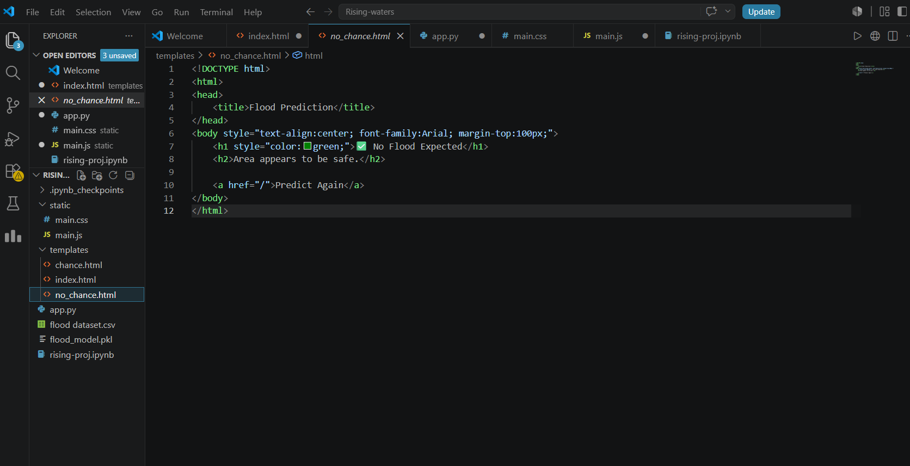
app.py :
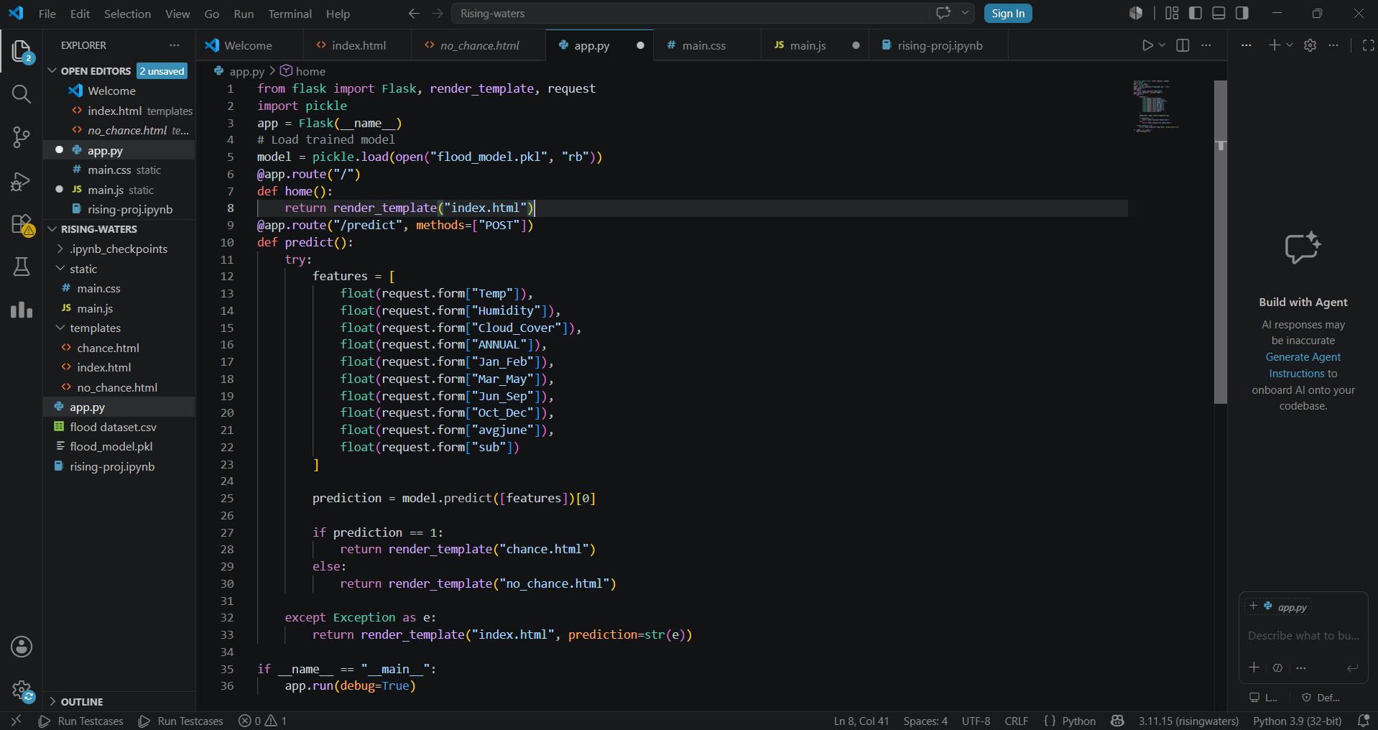
18. RESULTS
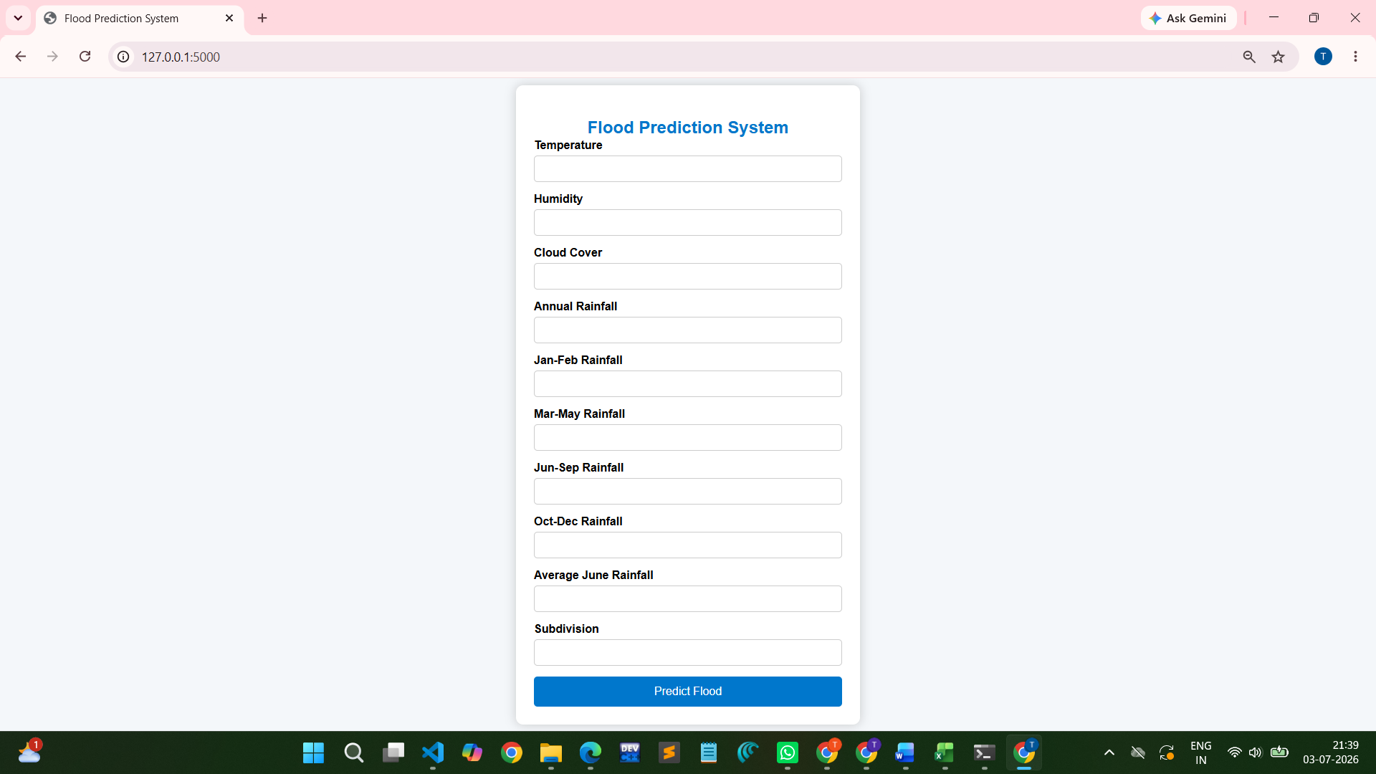
After entering the data :
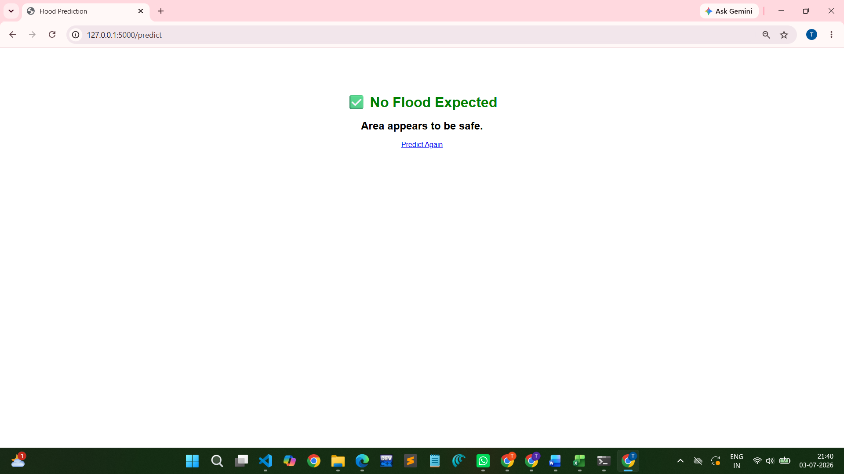
(Or)
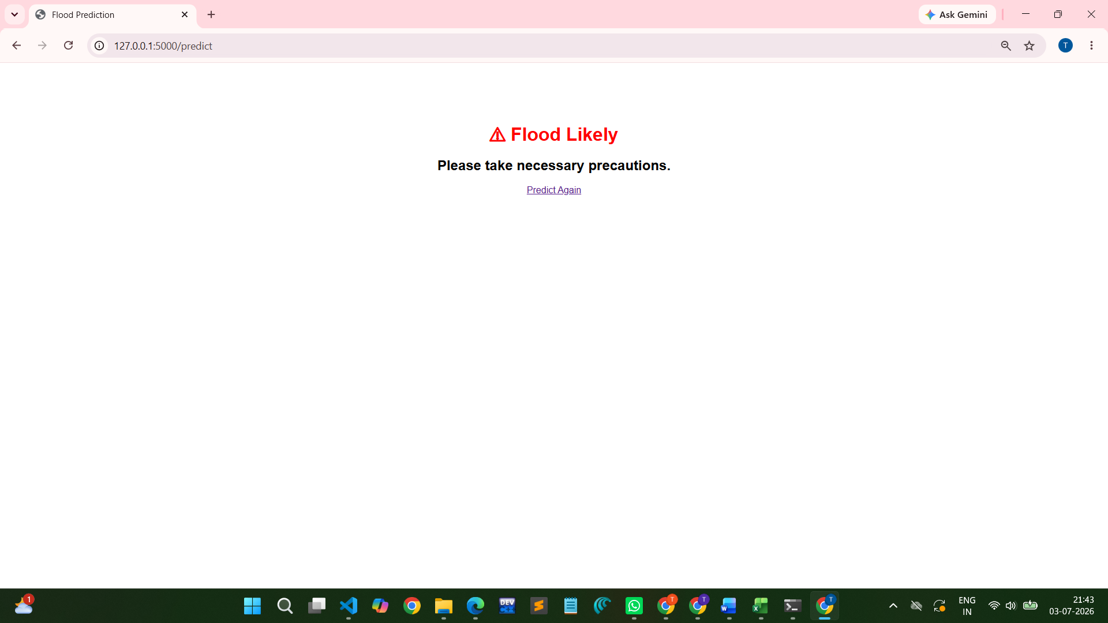
The system successfully predicts flood occurrence based on weather parameters.
The trained model achieved high prediction accuracy and was successfully integrated into a Flask web application.

19. FUTURE ENHANCEMENTS
- Live weather API integration
- GIS-based flood maps
- Mobile application
- SMS alert system
- Cloud deployment
- Deep Learning models

20. CONCLUSION
The Rising Waters project demonstrates how Machine Learning can be effectively used for flood prediction using historical weather data. The Flask-based web application provides a simple interface for entering environmental parameters and obtaining instant predictions. The project can support early warning systems and disaster management efforts, helping reduce the impact of floods on communities and infrastructure.

